For Immediate Release: 14/7/2015
Stephanie Pau
Citizen Inventor Limited, UK
steph@citizeninventor.com

Galactic Fête
A Summer Festival Celebrating the Mix of Space, Art and Maker Culture.
Find an expression for your creativity, hands on.

London, UK: There are plenty of festivals going on during the summer but nothing is like the Galactic Fête! Galactic Fête is a summer festival celebrating the mix of space, art and maker culture, hands on. 18/19 July LONDON.
The common thing about space, art and maker culture is inspiration. Who doesn't want to have some inspiration in a relaxed, merry, summer weekend?!
With inspiration comes creativity. Ever had the trouble of not knowing where to start implementing with your new idea or think that you are not in a place to do so? Creation, needs skills, at least a rough idea of. Here's where the maker culture helps - with its focus on using and learning practical skills and applying them. Now, that sounds like hard work, too much hard work for the weekend, at least.
Or is it?
At Galactic Fête, we will break it down and provide that a gentle starting point to creativity by giving you a variety of experiences in bite-sized hands-on workshops, smoothed by the refreshments and games. There will be a spectrum of activities ranging from getting yourself transformed into a space cat on portrait, to screen-printing, laser cutting your own space themed masterpiece, to hands on learning to build spacecrafts. We have something for you regardless of where you are on your journey. On Saturday evening, we'll have a star party - where you can observe the sky, top up with more food and enjoy one of the many crafty things of the weekend: craft beer. All that, at an unbelievably affordable price.
You, your family (children too) and friends are invited to come relaxed and celebrate creativity in action, at this art/space merry. You are more creative than you think!

Tickets: http://www.galacticfete.org/
Time: 18 Jul 10:30 - 19 Jul 17:00
Venue: Create Space London (Nearest station: Stonebridge Park)
About the organisers

Citizen Inventor is a platform and community that provides new avenues for citizens to get into science, engineering and technology. Galactic Fête falls under the remit of our space focused citizen science initiative: Space Town Hall.
http://www.citizeninventor.com/
http://www.spacetownhall.com/
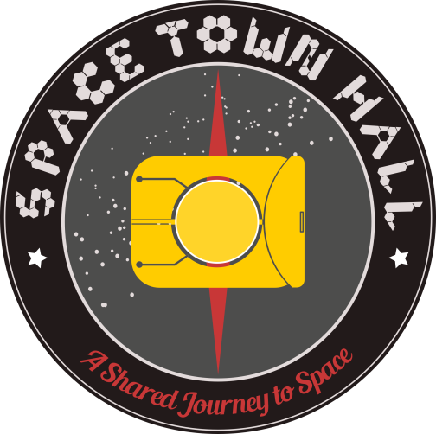

Create Space London is a probably the best equipped and most affordable multi-disciplinary open access workshops in the capital.

http://createspacelondon.org/

